Министерство науки и высшего образования Российской Федерации

Федеральное государственное бюджетное образовательное учреждение

высшего образования

«Волгоградский государственный технический университет»

|  |  |
| --- | --- |
| Факультет | Электроники и вычислительной техники |
| Кафедра | Программное обеспечение автоматизированных систем |

|  |  |  |  |  |  |  |  |  |  |  |  |  |  |  |  |  |  |  |
| --- | --- | --- | --- | --- | --- | --- | --- | --- | --- | --- | --- | --- | --- | --- | --- | --- | --- | --- |
| Согласовано | | | | | | | | |  | Утверждаю | | | | | | | | |
|  | | | | | | | | |  | Зав. кафедрой | | | | | | | | |
| (должность гл. специалиста предприятия) | | | | | | | | |  |
|  | | | |  |  | | | |  |  | | | |  | Ю. А. Орлова | | | |
| (подпись) | | | |  | (инициалы, фамилия) | | | |  | (подпись) | | | |  | (инициалы, фамилия) | | | |
| « |  | » |  | | | 20 |  | г. |  | « |  | » |  | | | 20 |  | г. |

**ПОЯСНИТЕЛЬНАЯ ЗАПИСКА**

|  |  |  |  |  |  |  |  |  |  |  |  |  |  |  |  |  |
| --- | --- | --- | --- | --- | --- | --- | --- | --- | --- | --- | --- | --- | --- | --- | --- | --- |
| к | выпускной квалификационной работе бакалавра | | | | | | | | | | | | | | | на тему |
| (наименование вида работы) | | | | | | | | | | | | | | | | |
| Разработка мобильного приложения для заказа и доставки еды | | | | | | | | | | | | | | | | |
|  | | | | | | | | | | | | | | | | |
|  | |  | | | | | |  |  | | | | | | | |
| Автор | |  | | | | | |  | Шеху Абубакар Умар | | | | | | | |
|  | | (подпись и дата подписания) | | | | | |  | (фамилия, имя, отчество) | | | | | | | |
| Обозначение | | | ВКРБ–09.03.04–10.19–16–23 | | | | | | |  | | | | | | |
|  | | | (код документа) | | | | |  | | | | | | | | |
| Группа | | | ПрИн-467 | | | | |  | | | | | | | | |
|  | | | (шифр группы) | | | | |  | | | | | | | | |
| Направление | | | 09.03.04 – Программная инженерия,  Разработка программно-информационных систем | | | | | | | | | | | | | |
|  | | | (код и наименование направления, наименование программы (профиля)) | | | | | | | | | | | | | |
| Руководитель работы | | | | |  | | | | | | | |  | | Гилка В.В. | |
|  | | | | | (подпись и дата подписания) | | | | | | | |  | | (инициалы и фамилия) | |
| Консультанты по разделам: | | | | | | | | | | | | | | | | |
|  | | | | | |  |  | | | | |  | |  | | |
| (краткое наименование раздела) | | | | | |  | (подпись и дата подписания) | | | | |  | | (инициалы и фамилия) | | |
|  | | | | | |  |  | | | | |  | |  | | |
| (краткое наименование раздела) | | | | | |  | (подпись и дата подписания) | | | | |  | | (инициалы и фамилия) | | |
| Нормоконтролер: | | | |  | | | | | | |  | Кузнецова А.С. | | | | |
|  | | | | (подпись и дата подписания) | | | | | | |  | (инициалы и фамилия) | | | | |

Волгоград 2023 г.

Министерство науки и высшего образования Российской Федерации

Федеральное государственное бюджетное образовательное учреждение

высшего образования

«Волгоградский государственный технический университет»

|  |  |
| --- | --- |
| Кафедра | Программное обеспечение автоматизированных систем |

|  |  |  |  |  |  |  |  |  |  |
| --- | --- | --- | --- | --- | --- | --- | --- | --- | --- |
|  | Утверждаю | | | | | Зав. кафедрой | | | |
|  |  | | | |  | Ю. А. Орлова | | | |
| (подпись) | | | |  | (инициалы, фамилия) | | | |
|  | « |  | » |  | | | 20 |  | г. |

**Задание**

|  |  |  |  |  |  |  |  |  |  |  |  |  |  |  |  |
| --- | --- | --- | --- | --- | --- | --- | --- | --- | --- | --- | --- | --- | --- | --- | --- |
| на | выпускную квалификационную работу бакалавра | | | | | | | | | | | | | | |
|  | (наименование вида работы) | | | | | | | | | | | | | | |
| Студент | | | Шеху Абубакар Умар | | | | | | | | | | | | |
|  | (фамилия, имя, отчество) | | | | | | | | | | | | | | |
| Код кафедры | | | | 10.19 | Группа | | | | ПрИн-467 | | | |  | | |
| Тема | | Разработка мобильного приложения для заказа и доставки еды | | | | | | | | | | | | | |
|  | | | | | | | | | | | | | | | |
| Утверждена приказом по университету | | | | | | « | 06 | » | | сентября | 20 | 22 | | г. № | 1235-ст |
| Срок представления готовой работы (проекта) | | | | | | | | | |  | | | | | |
|  | | | | | | | | | | (дата, подпись студента) | | | | | |
| Исходные данные для выполнения работы (проекта) | | | | | | | | | | | | | | | |
| Задание, выданное научным руководителем кафедры «ПОАС» | | | | | | | | | | | | | | | |
|  | | | | | | | | | | | | | | | |
| Содержание основной части пояснительной записки | | | | | | | | | | | | | | | |
|  | | | | | | | | | | | | | | | |
|  | | | | | | | | | | | | | | | |
|  | | | | | | | | | | | | | | | |
|  | | | | | | | | | | | | | | | |
|  | | | | | | | | | | | | | | | |
|  | | | | | | | | | | | | | | | |
|  | | | | | | | | | | | | | | | |
|  | | | | | | | | | | | | | | | |
|  | | | | | | | | | | | | | | | |

|  |
| --- |
|  |
|  |
|  |
|  |
|  |

|  |  |
| --- | --- |
| Перечень графического материала | |
| 1) |  |
|  | |
| 2) |  |
|  | |
| 3) |  |
|  | |
| 4) |  |
|  | |
| 5) |  |
|  | |
| 6) |  |
|  | |
| 7) |  |
|  | |
| 8) |  |
|  | |
| 9) |  |
|  | |
| 10) |  |
|  | |
| 11) |  |
|  | |
| 12) |  |
|  | |

|  |  |  |  |  |  |  |  |
| --- | --- | --- | --- | --- | --- | --- | --- |
| Руководитель работы (проекта) | |  | |  | | Гилка В.В. | |
|  | | (подпись и дата подписания) | |  | | (инициалы и фамилия) | |
| Консультанты по разделам: | |  | | | |  | |
|  |  | |  | |  | |  |
| (краткое наименование раздела) |  | | (подпись и дата подписания) | |  | | (инициалы и фамилия) |
|  |  | |  | |  | |  |

Министерство науки и высшего образования Российской Федерации Федеральное государственное бюджетное образовательное учреждение высшего образования

«Волгоградский государственный технический университет»

Кафедра «Программное обеспечение автоматизированных систем»

|  |  |
| --- | --- |
|  | УТВЕРЖДАЮ:  Зав. кафедрой ПОАС  ________________Ю.А. Орлова  «____» _______________20 г. |

Разработка мобильного приложения для заказа и доставки еды

ПОЯСНИТЕЛЬНАЯ ЗАПИСКА

ВКРБ–09.03.04–10.19–16–23–81

Листов 65

|  |  |
| --- | --- |
|  | Руководитель работы  ________________Гилка В.В.  _________________________  «___» ________________20 г. |
| |  | | --- | | Нормоконтролер  ______________ Кузнецова А.С.  «___» __________________ 20 г. | | |  | | --- | | Исполнитель  студент группы ПрИн-467  _______________Шеху А.У. «___»________________ 20 г. | |

Волгоград, 2023 г.

Annotation

This document is an explanatory note to the bachelor's final qualifying work on the topic: "Development of a mobile application for ordering and delivering food."

The paper substantiates the relevance of the chosen topic, conducts a comparative analysis between virtual tours of universities, analyzes the current process of distributing information about the department "Software of automated systems" among applicants, proposes an updated process, puts forward requirements for the functional characteristics of the virtual tour, draws up a list of panoramas and a scenario of transitions between panoramas, contains a detailed description of the implementation of the virtual tour, describes test examples.

The document includes 65 pages, 44 figures, and 3 appendices.

Keywords: virtual tour, 3d, panoramas, transition points, photos.

Content

Introduction 7

1 Requirement analysis and domain modeling 8

1.1 Domain analysis 8

1.2 Justification of the choice of the platform 9

1.3 Purpose of the mobile application 12

1.4 Overview of development analogues 13

Introduction

With the increasing availability of mobile Internet, mobile applications have become increasingly popular, so ordering goods and services from smartphones is becoming more frequent. This is due to the fact that the mobile application is the most convenient way to interact with such services. The mobile application allows you to make an order without unnecessary inconvenience and at any convenient moment: at work, during a walk, at school and the like.

The traditional scheme of ordering and delivering food looks like this: customers place an order by phone at the selected institution and wait for the courier to deliver their order to the selected address. However, modern technologies offer us unlimited opportunities and, therefore, the integration of digital methods and rapid response to new trends will change the market. Nowadays, most people who are used to making purchases through websites and apps are waiting for a similar experience when ordering food. The most attractive qualities of online orders for people will always be comfort, prompt delivery and reasonable prices.

Establishments that have the opportunity to purchase takeaway food must keep up with the times and implement applications to make their services accessible and retain customers. Ordering food through a mobile app will allow you to quickly deliver food without any interaction with other people.

Food and ready-to-eat delivery was very popular after the first wave of the pandemic. The pandemic has greatly increased the demand for the use of applications and during the entire period of self-isolation, the turnover, the number of payments, as well as the average receipt of food delivery services have increased. During these few months, the market has gone a way that would normally take at least a year. The volume of orders continued to grow even in the summer, as people continued to stay at home and order food [1].

The purpose of the work is to increase the level of visibility of information about the Department of POAS on the Internet by creating a virtual tour.

Tasks:

- perform an analysis of the subject area;

- to review existing analogues and identify their advantages and disadvantages;

- determine the requirements for the mobile application being developed;

- to design the database based on the requirements;

- generate panoramas based on photos of scenario points;

- mobile application development;

- test the developed software tool and prove its operability and effectiveness.

The object of research in the work is the use of a virtual tour in solving problems of increasing informativeness and visibility.

The subject of the study is "Ordering food"

Research methods. Methods of mathematical modeling, system analysis, software engineering, object-oriented programming, human-machine interaction design technologies were used to solve the tasks.

The practical value of the work lies in the fact that the developed virtual tour will increase the informativeness and visibility of the POAS department for applicants entering the Volgograd State Technical University (VolgSTU) in the direction of "Software Engineering".

# 1 Requirement analysis and domain modeling

# 1.1 Domain analysis

As part of the final qualifying work, the development of a mobile application for ordering and delivering food is being considered. The application does not belong to any organization or any active restaurant.

The subject of the activity of the online food ordering and delivery platform is:

− connects consumers with a broad range of local restaurants and food, so they can order from the full menus of their local favorites whenever they want.

− services for providing food to consumers, regardless of whether they are served in special public catering places or in self-service restaurants, eat them indoors, take them with you or order with home delivery;

− preparation and delivery of food for direct consumption;

− activities of catering establishments with takeaway service;

A customer is a person who makes an order at any restaurant on the delivery platform "SoftEats". To place an order at the SoftEats, the customer open the application, passes registration or authorization (specifying his name, address and mobile phone number), then adds the foods he needs from a specific restaurant to the cart and leave his order to the operator.

Each restaurant on SoftEats has a manager who accepts and confirms order, changes the menu and price list, adds various promotions and promo codes.

The courier is a person registered with SoftEats to deliver food to consumers from a specific restaurant to their desired address. A courier can deliver food either on foot, by bike, scooter or private car.

# 1.2 Justification of the choice of the platform

According to a report by Statista, as of 2021, there are approximately 5.2 billion mobile phone users worldwide. This number is expected to reach 5.4 billion by 2023. It is stated that the average person spends about 3 hours and 15 minutes on their smartphone daily, most of that time being spent on social media, messaging apps, and video streaming platforms. It is expected that the use of mobile devices will soon continue to increase as more people rely on them for communication, entertainment, and internet access. The increasing popularity of 5G technology is also expected to contribute to the growth in mobile device usage, as it offers faster speeds and more efficient connections.

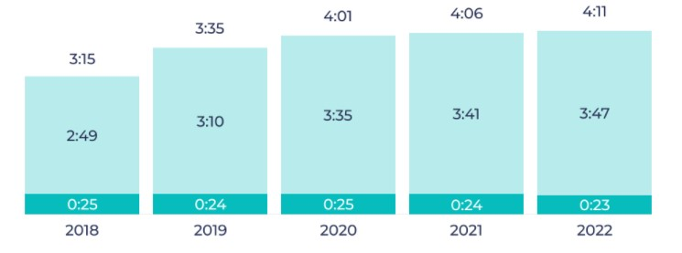

Figure 1.1 – Average daily usage of apps and browsers

It is essential to consider which platforms to target for the app. In 2021, the two dominant platforms were iOS and Android, with a combined market share of over 99%. According to Sensor Tower, the App Store had over 2 million apps available in 2021, with over 140 billion downloads. This represents a 10% increase in app availability and a 25% increase in downloads compared to the previous year.

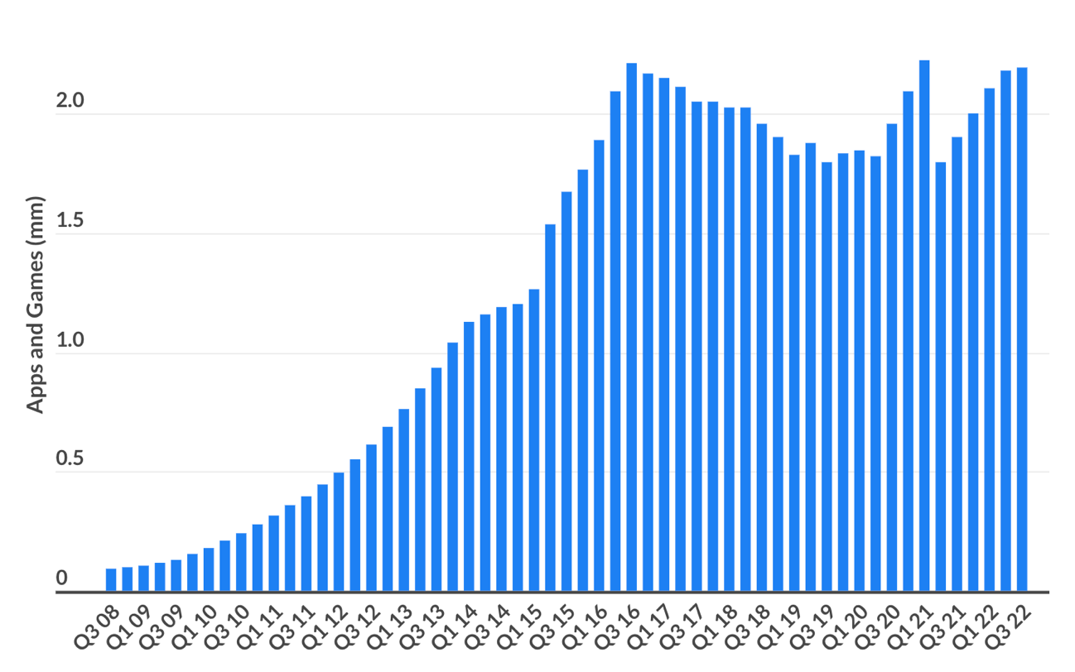

Figure 1.2 – Number of apps on the Apple App Store

The Google Play Store also saw significant growth, with over 3.5 million apps available and over 240 billion downloads in 2021. This represents a 20% increase in app availability and a 30% increase in downloads compared to the previous year.

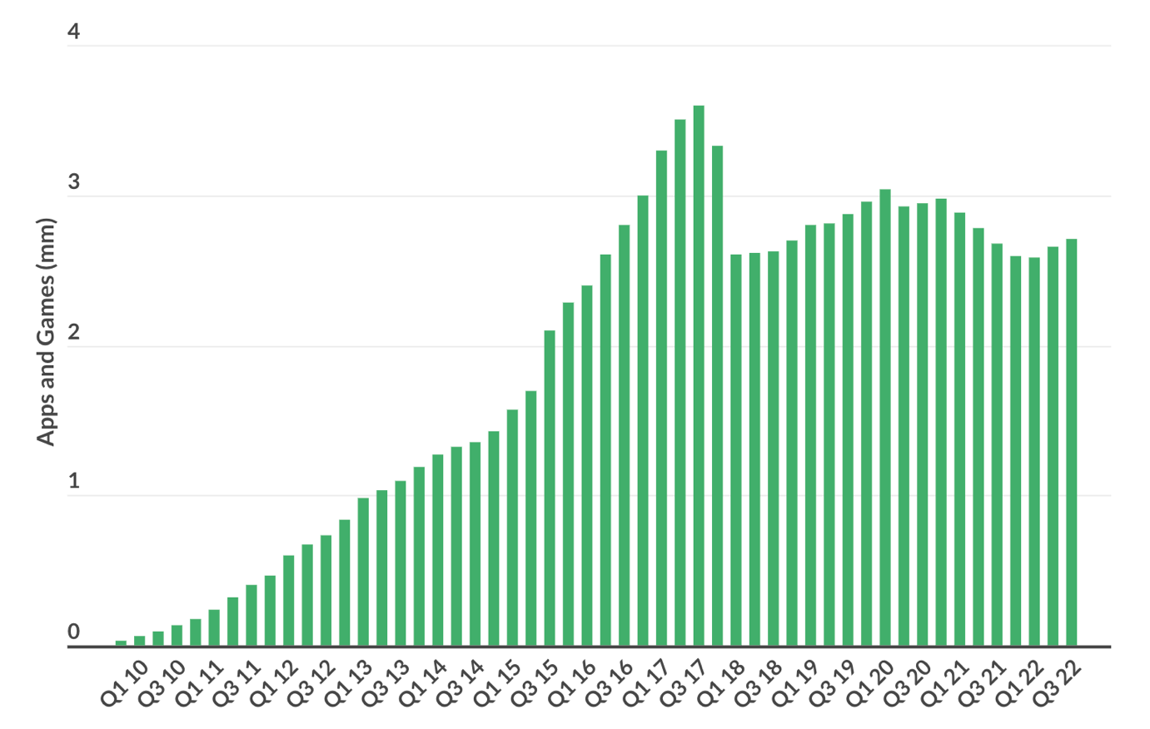

Figure 1.3 – Number of apps on Google Play

Based on the platform overview and mobile app download statistics, choosing iOS and Android platforms for development can help one reach a wider audience and potentially increase the success of the app. Thus, a cross-platform application will be developed, and therefore a platform for hosting applications - the App Store and Google Play

# 1.3 Purpose of the mobile application

Mobile applications for the SoftEats online food ordering and delivery platform should solve the following tasks:

1. The possibility of the customer making an order by adding various items to the cart and the possibility of deleting them.

2. The possibility of using auction promo codes for orders.

3. The client receives information about previously placed orders.

4. The possibility of user registration in the application.

5. The possibility of courier to accept or decline delivery

The creation of this software product pursues the following goals:

1. Acceleration and simplification of the implementation of the order.

2. Increasing the flow of new customers.

3. Quick search for desired positions of dishes.

4. The possibility of introducing new profitable promotions.

The formal formulation of the problem is described as follows:

Input data:

− menu information;

− information about the client (name, address, phone number).

− information about the courier (name, address, phone number).

Input resources:

− payment system;

− client.

Input controls:

− procedure for selecting the quantity of goods;

− the procedure for choosing a dish;

− procedure for choosing the type of payment;

− procedure for selecting the type of delivery.

Output streams:

− check;

− order.

# 1.4 Overview of development analogues